# Experiment No.: 02 Pressure to Current Converter

|  |  |
| --- | --- |
| **Academic Year** | **: 2021-22 Sem : I** |
| **Class** | **: TY BTech Instrumentation & Control** |
| **Course Name** | **: Process Instrumentation** |
| **Course Code** | **: IC3231** |
| **Name** | **: Shaunak Deshpande** |
| **Division** | **: IC-C** |
| **Roll No.** | **: 39** |
| **G.R. No.** | **: 11911180** |

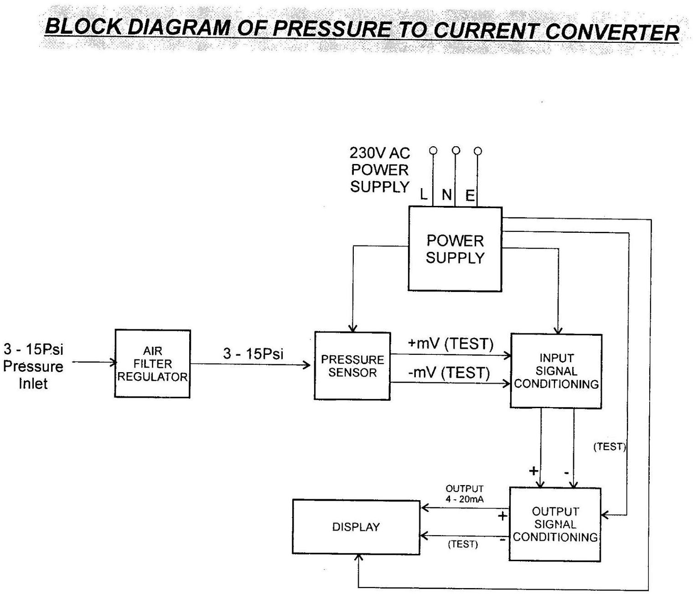

**Experiment No.: 02**

**Pressure to Current converter**

**Aim :** To study and plot the calibration curve of Pressure to Current converter.

**Apparatus :** Pressure to Current converter, Compressor, Digital multimeter, Pressure gauge, piping, connecting wires etc.

### Theory :

**Principle of operation:**

A precision voltage reference circuit supplies a static and highly regulated voltage to all other portions of the circuit. An excitation circuit drives the solid state, piezo-resistive transducer which has configuration of a Whetstone‟s bridge upon the application of pressure to the transducer, a force and resultant strain, cause the bridge to become unbalanced in direct portion to the applied pressure. The voltage thus obtained is amplified, scaled and summed with another reference voltage to produce the output current source signal.

### Specifications of Pressure to Current converter :

Input : Instrument air 3-15 psig.

Output : 4-20 mA DC Power supply : 230VAC, 50Hz Power Consumption : Less than 10 VA

Max. Pressure : 1.5 times max pressure range. Burst Pressure : 2 times max pressure range. Accuracy : ± 0.25 % of span

Hysteresis : ± 0.1 %

Repeatability : ± 0.1 % span

Resolution : ± 0.1 %

Response time : 50 mS to 99% of step change Relative Humidity : 5-95 % at 25°C.

Operating Temperature : 0 to 55°C

Display : 8 * 1 Alphanumeric LCD

### Procedure :

1. Switch on the compressor and let the pressure build up to 20 psi.
2. Make the connections as per the circuit diagram.
3. Vary the pressure gradually by using AFR and note down the corresponding current reading on DMM. Take 5 readings up to 15 psi.
4. Now gradually close the valve and again note down the current reading for same value of pressure.
5. Plot the graph for increasing as well as decreasing readings.
6. Calculate the % error and sensitivity.

**Sample calculation: -**

% Error = [(Required –Actual) / Span ] * 100

**Conclusion:**

1. In this practical, we have successfully understood the working and the principal of pressure to current (P to I) convertor.

2. We have implemented this practical to convert the input pressure of (3-15 psi) to output current of (4-10 mA DC).

3. We learned about calibrating the instrument for getting accurate readings, and implemented the same.

4. Also, after the experiment, we are able to detect any faults which maybe present in the instrument.

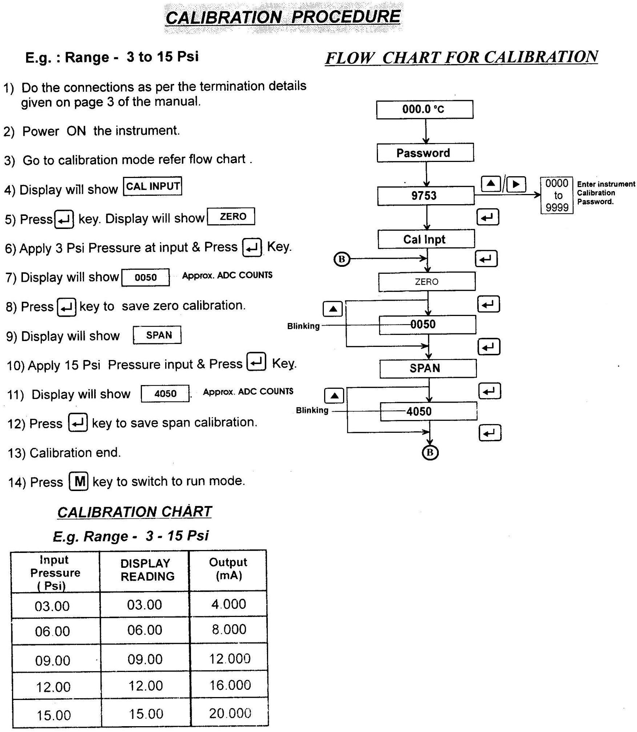

**Screenshots of the Tasks completed on the Virtual Lab:**

(Introduction, Configuration, Connections, Characterization, Calculations, Calibration, Final observation Table, Fault Finding, etc.)

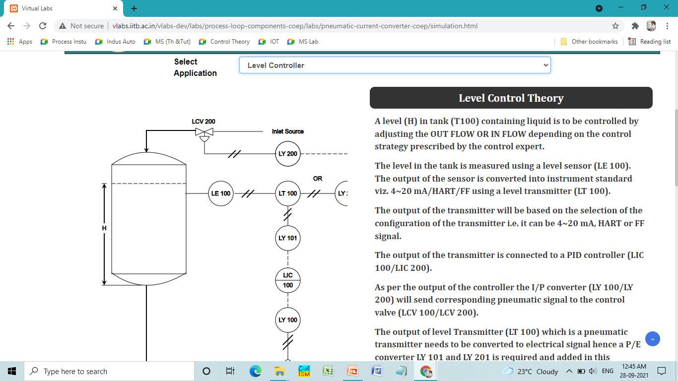

1. **Introduction**

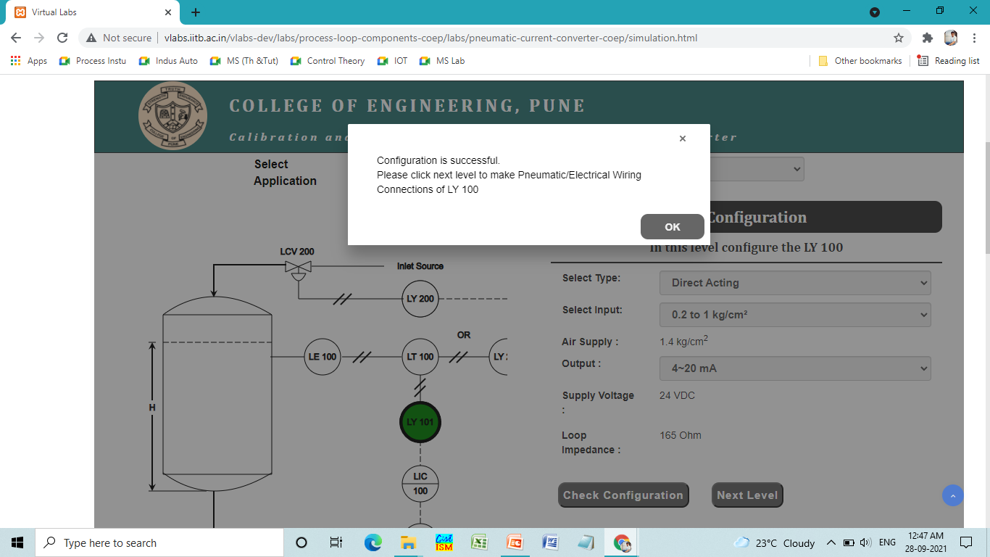

1. **Configuration**

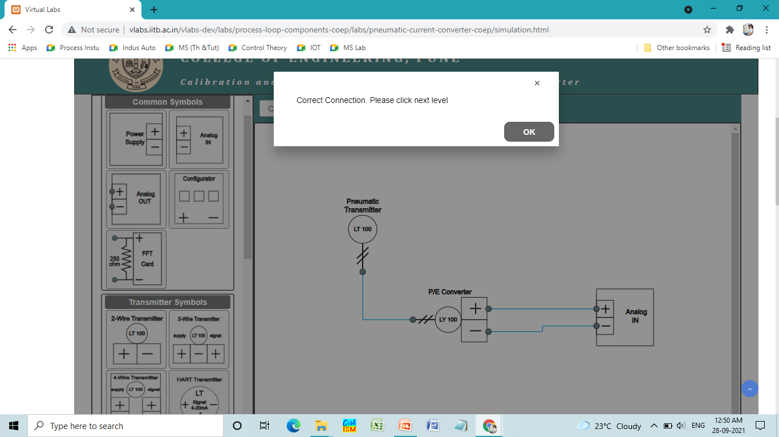

1. **Connections**

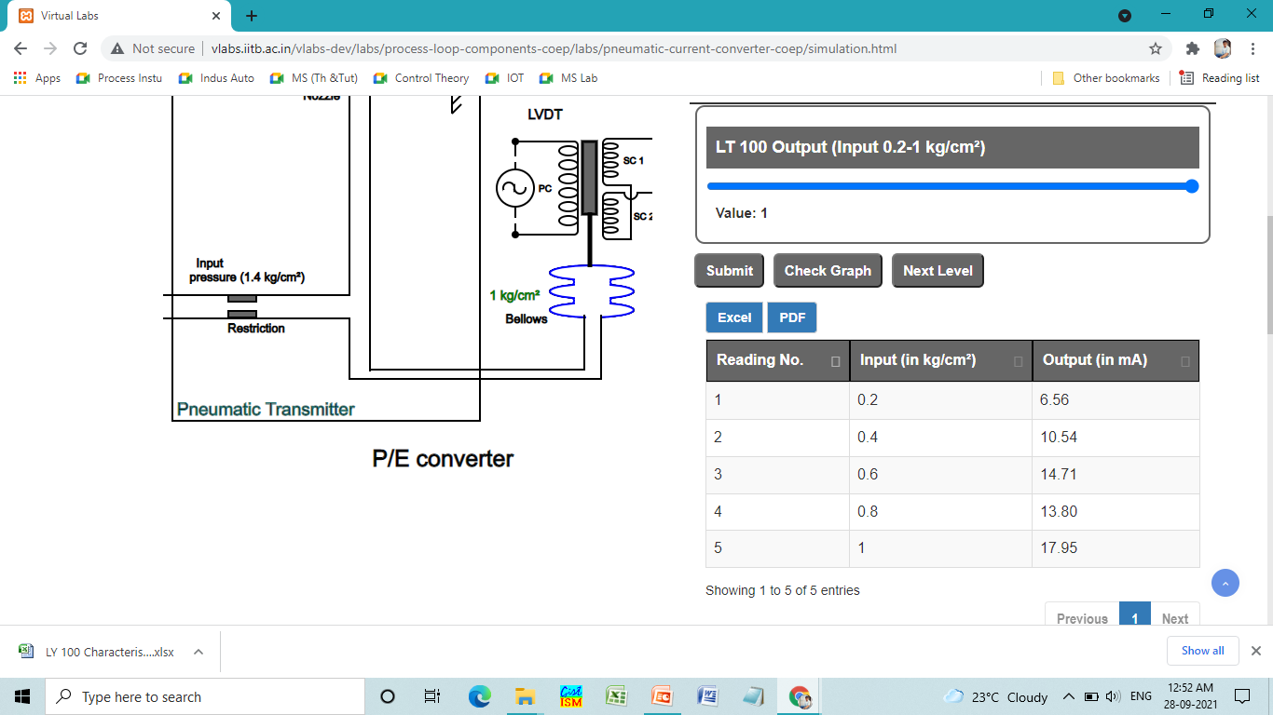

1. **Characterization**

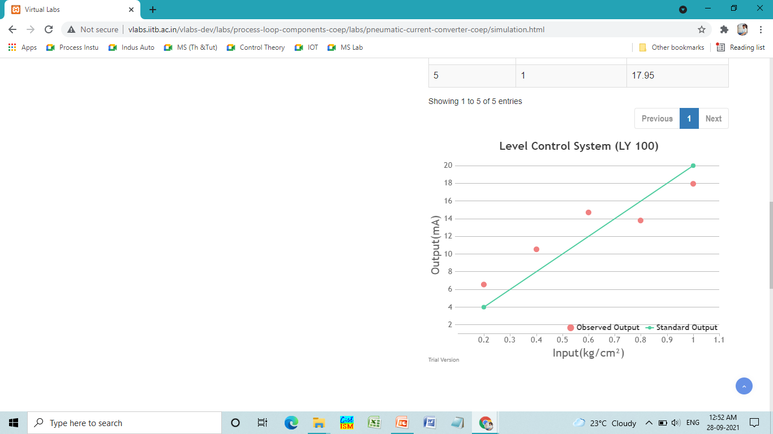

1. **Observation Graph**

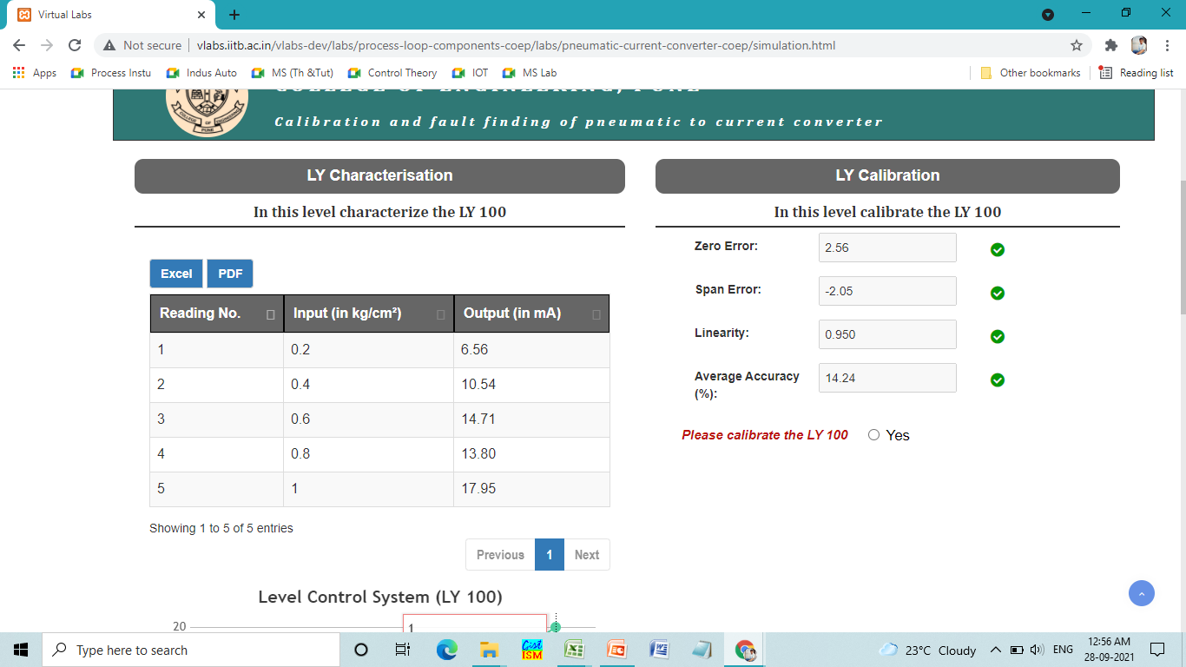

1. **Calibration**

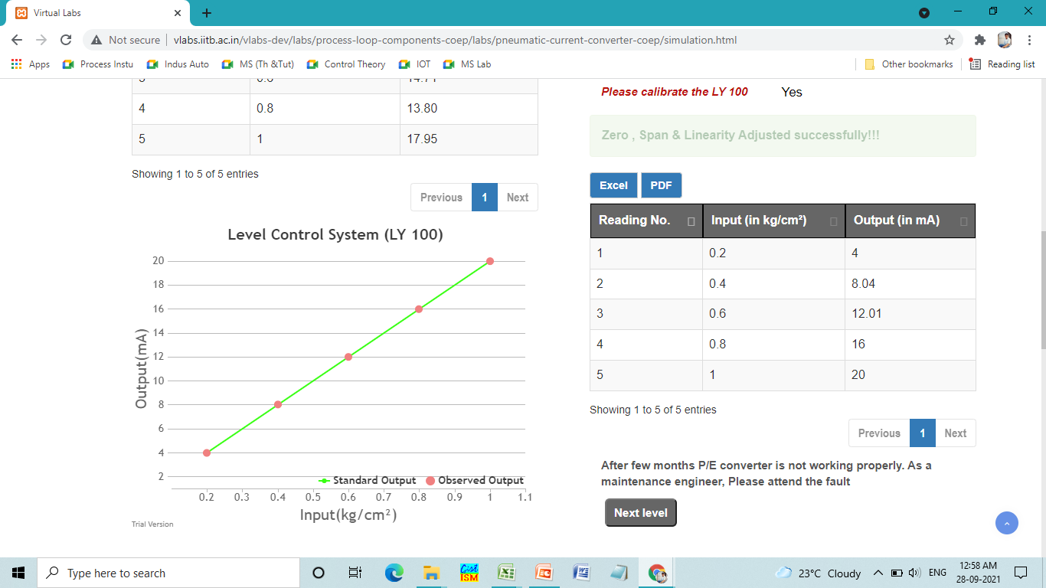

1. **Final Observations**

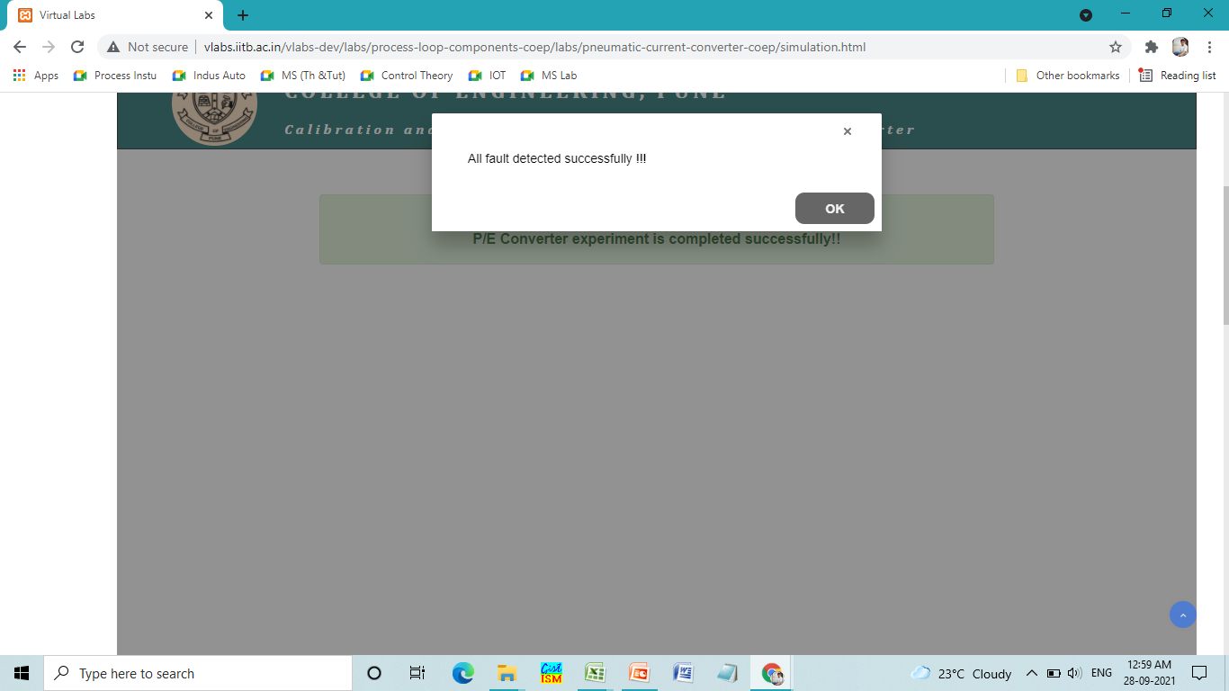

1. **Fault Detection**